Zahava Gopin

1/6/23

WEB- 340: Assignment 1.2

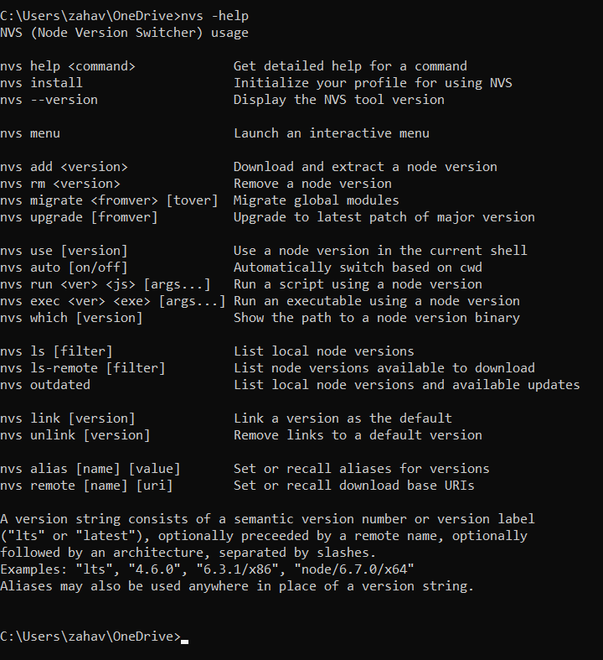NVS Help menu:

Node.js version:

NPM version:

Node.js help menu:

Open Chrome’s developer tools and inspect the file. Take a screenshot of the inspect debugger window:

